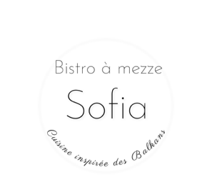
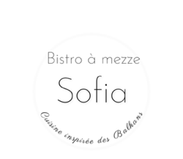
MENU
Cold mezze

Kalamata olives (VG, SG) | 4 - | Roasted nuts with rosemary (VG, SG) | 5 -
Marinated roasted peppers with dill, house made | 4 - | Bulgarian feta with olive oil and paprika (V, GF) | 7 -
Turshia (picked vegetables) | 7 - | Lyuténitza - roasted red pepper spread with tomatoes (VG, GF) | 8 -
Kyopolou - roasted eggplant spread with pepper, garlic, parsley (VG, GF) | 8 - | Snéjanka -“Snow white salad” with strained yogurt (without gelatin) pickles, dill, garlic,  walnuts (V, GF) | 8 -
Trio tapenade - lyuténitza, kyopolou, snéjanka (V, GF) | 14 - | Plateau de fromages - assorted Balkan cheeses  (V, GF) | 18 -
Plateau de charcuteries - artisanal charcuterie, locally sourced, traditional Balkan method (GF) | 21 - | Plateau mixte - assorted cheese and charcuteries (GF) | 23 -
Plateau Sofia - cold mezze sampler : lyuténitza, kyopolou, snejanka, grilled peppers with dill, Kalamata olives, cheese, charcuteries | For 2 : 26 -  For 4 : 38 -
Hot mezze
Tikvichki -fried zucchini with yogurt, garlic, dill sauce (V) | 9 - | House fries with mayonnaise (V)  with feta (V) | 7 -  9 -
Banitza - traditional Bulgarian house-made filo pastry with feta (V) | 9 - | Kashkaval pané - breaded Bulgarian cheese (V) | 10 -
Soudjuk grillé - lamb and beef sausage with cinnamon (Turkish recipe) | 10 -
Soupe du jour | 7 -

Salads
Shopska salata - cucumber, tomatoes, peppers, shallots, olives, feta (V, GF)  Grilled vegetable salad with Quebec goat cheese gratiné on baguette (V, GF) | 12 –  16 - | Salade Elena - lettuce, filet Elena (Bulgarian dry cured meat), tomatoes, cucumbers, Kalamata olives, onions, hard-boiled eggs (organic, from free-range chickens), homemade croutons | 16 -
Skara - from the grill (served with salad and choice of house fries or grilled vegetables)
Kuftéta - traditional Bulgarian beef and pork meatballs (GF) | 17 - | Soudjuk - lamb and beef sausage with cinnamon (Turkish recipe) | 17 -
Kebapcheta -Bulgarian kababs with beef and pork (GF) | 17 - | Karnaché - traditional Bulgarian sausage with pork and paprika | 19 -
Chicken - daily special based on seasonal availability and chef's inspiration (pasture-raised chicken from the Bouffe-Or farm)  Lamb - daily special based on seasonal availability and chef's inspiration (pasture-raised lamb from the Bouffe-Or farm) | 19 -  28 - | Meshana skara - mixed grill with choice of three grilled meats (choice between kabache, kufte, karnaché, chicken) | 26 -
Vegetarian mains (served with a salad)
Kashkaval pané - breaded Bulgarian cheese, served with a choice of house fries or grilled vegetables (V) | 17 - | Imam Bayildi - roasted eggplants stuffed with vegetables with a gratin of Balkan cheeses (V, GF) *vegan option without cheese | 17 -
Feta au four -Bulgarian feta baked in a traditional clay oven pot with tomatoes and egg (optional: with spicy marinated pepper) (V, GF) | 17 - | Piperade des Balkans - peppers, tomatoes, onion, made and served in a traditional clay oven pot (VG, GF) | 15 -
Desserts

House baklava | 5 - | Duo halva and lokum (sweets from Greece and Turkey) | 6 -
Sheep’s milk yogurt with honey and walnuts | 7 -
V = vegetarian / VG = vegan / GF = gluten free |  | Please advise us if you have any food allergies or restrictions so that we can accommodate your needs.

